**Document: Explanation of the SignIn Component** [**https://citria.org/sign-in**](https://citria.org/sign-in)

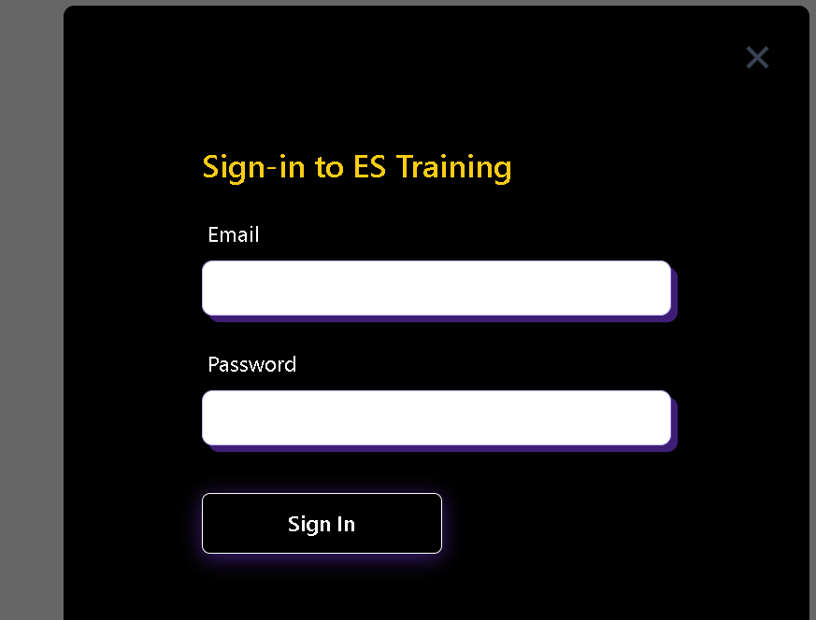

The provided code is a React component named SignIn responsible for rendering a sign-in form in a web application. Here is an overview and explanation of the key features and functionalities:

Component Structure:

Import Statements:

The component imports necessary modules and components, including React hooks (useContext, useEffect, useState), external libraries (axios, react-google-recaptcha), and various UI components (e.g., IoCloseSharp for a close icon).

State Initialization:

The component uses the useState hook to manage state variables such as loading, formData, formErrors, and captcha.

Context and Navigation:

The component utilizes the useContext hook to access the application context, allowing it to interact with shared state and functions.

The useNavigate hook is used to handle navigation within the application.

Effect Hook:

The useEffect hook is employed to check for an existing authentication token. If found, it redirects the user to a specified location.

Form Handling:

The handleChange function updates the component's state in response to user input.

The validateForm function checks for form validation errors based on the entered email and password.

Form Submission:

The handleSubmit function is triggered on form submission. It performs form validation, checks the CAPTCHA verification, and sends a sign-in request to the server using Axios.

If successful, it stores the authentication token in local storage and updates the application state.

CAPTCHA Integration:

The component incorporates the react-google-recaptcha library to provide CAPTCHA functionality, enhancing security.

UI Rendering:

The component renders a styled sign-in form with input fields for email and password.

It includes error messages for validation issues and a CAPTCHA widget.

Conditional Rendering:

A loading spinner is displayed while the sign-in process is in progress.

Close Button:

A close button (IoCloseSharp) allows users to close the sign-in modal.

Navigation Links:

Links for user actions, such as creating a new account (/sign-up) and resetting the password (/forgot-password), are provided.

Google Sign-In:

The component includes a component for signing in with Google (GoogleSignIn).

Conclusion:

The SignIn component encapsulates the logic and UI elements necessary for user authentication. It employs React hooks, form validation, CAPTCHA integration, and navigation to create a seamless sign-in experience for users.